Access for Success

Differentiation by Linguistic Complexity Templates

Option A: Building Materials
Circle the correct answers.

The tower/lighthouse is made of concrete/glass.

The house/doghouse is made of brick/glass.

The house/doghouse is made of wood/brick.

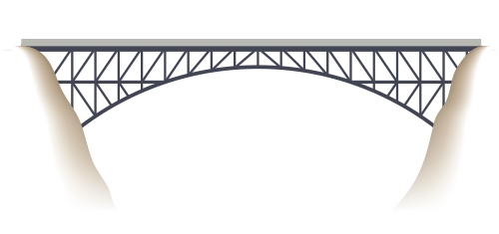

The lighthouse/bridge is made of metal/brick.

Access for Success

Differentiation by Linguistic Complexity Templates

Option B: Building Materials

Structures
house
doghouse
lighthouse
bridge
tower

Materials
concrete
wood
brick
metal
glass

Add the missing words.

The _____________________ is
made of ____________________.
The _____________________ is
made of ____________________.

The _____________________ is
made of ____________________.

The _____________________ is
made of ____________________.

Access for Success

Differentiation by Linguistic Complexity Templates

Option A: Coral Reefs

Collaborative exploration
Using information from your individual and collective research, respond to the questions. First, respond to the questions you know using your own research. Then, with your group members, compare answers to the questions and add details to your answers using their information.
1. Where are coral reefs found? | 2. Describe the appearance of coral. | 3. Draw several examples of coral. | 4. What do you need to do to observe coral in their habitat?
5. How do coral help the environment? | 6. What are threats to coral? | 7. How do tourists and tourism affect coral reefs? | 8. How does trash/waste in the ocean affect coral?
9. What is being done now to help coral? | 10. What else needs to be done to support the health of coral reefs? | 11. How has research helped us learn more about coral reefs? | 12. In your opinion (and also that of your group), what was the most interesting thing you learned about coral?
Other important ideas

Access for Success

Differentiation by Linguistic Complexity Templates

Option B (less complex than Option A): Coral Reefs

Collaborative exploration
Part 1: Respond to the following four questions with the information you have collected/gathered about coral.
1. Describe coral. | 2. Draw two examples of coral. | 3. What hurts coral? | 4. How do coral help us?
Part 2: Respond to the following four questions by asking four different classmates about what they know about coral and writing their responses in the boxes below.
1. Where are coral reefs? | 2. How does trash in the ocean hurt coral? | 3. What can be done to protect coral? | 4. What was the most interesting thing you learned about coral?
Other important ideas

